# Homework: JavaScript Development Introduction

This document defines the homework assignments from the [“JavaScript Basics“ Course @ Software University](http://softuni.bg/courses/javascript-basics/). Please submit as homework a single zip / rar / 7z archive holding the solutions (source code) of all below described problems.

## Home Town

Write a JavaScript code **hometown.js** that shows your hometown in a popup browser window (alert). Crate a HTML page **hometown.html** that executes your JavaScript code. A sample result (when you open the HTML page in Chrome Web browser) might be the following:

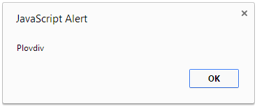

## Numbers 1...10

Write a JavaScript program **numbers1to10.js** that prints on the console the numbers from 1 to 10 (each at a separate line). Run the program through **Node.js**. Example:

|  |  |
| --- | --- |
| **Command** | **Output** |
| node numbers1to10.js | 1  2  3  4  5  6  7  8  9  10 |

## Current Time

Write a JavaScript program **current-time.js** that prints on the console the current time in format **hours:minutes**. The hours should be printed without leading zeroes. The minutes should be printed as two-digit number with a leading zero when needed. Execute your program through **Node.js**. A few sample outputs are given below:

|  |  |
| --- | --- |
| **Input** | **Output** |
| (no input) | 21:03 |
| (no input) | 9:57 |
| (no input) | 16:30 |
| (no input) | 6:00 |
| (no input) | 23:59 |

## Circle Area

Write a JavaScript function **calcCircleArea(r)** that takes as a parameter the **radius of a rectangle** and calculates and returns its area. Put the function in a file named **circle-area.js**. Write a HTML page **circle-area.html** that includes the script **circle-area.js** and calculates and prints in the page body the area of circles of size r=7, r=1.5 and r=20. Examples:

|  |  |  |
| --- | --- | --- |
| **Input** | **Output** |  |
| 7 | 153.93804002589985 |
| 1.5 | 7.0685834705770345 |
| 20 | 1256.6370614359173 |
|  |  |

## Decimal to Hexadecimal

Write a JavaScript code in a Web page **dec2hex.html** that enters a positive integer number **num** and converts and converts it to a hexadecimal form. The input should be entered as JavaScript **prompt** window. The output should be shown as browser popup window (**alert**). Examples:

|  |  |  |
| --- | --- | --- |
| **Input** | **Output** |  |
| 254 | FE |
| 6779 | 1A7B |
| 10941298 | A6F372 |
| 65535 | FFFF |
| 0 | 0 |

# Problems for Champions

The next few problems are not mandatory. Implement them to challenge your skills.

## ** Tic-Tac-Toe

Implement the classical [Tic-Tac-Toe game](http://en.wikipedia.org/wiki/Tic-tac-toe) in JavaScript. Players play one after another. Use HTML to display the play field and JavaScript to implement the game logic. The screenshot below shown how your game might look like:

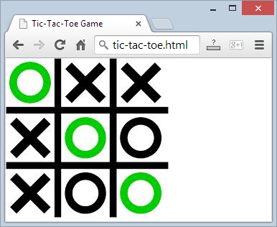

## *** Falling Rocks Game

Implement the "Falling Rocks" game in **JavaScript**. The player stays at the bottom of the screen and can move left and right (by the arrows keys). A number of rocks of different sizes and forms constantly fall down and the player needs to avoid a crash. An example how the game might look like is show below:

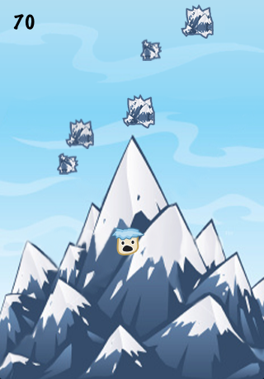

You are free to implement your own graphics, as well to add more game objects to make the game play more interesting.